**A user not authorized has right access to validate a work order**

User 459291_FR can see a work order assigned to BP2I-BE-DC in VDC and MAM. This situation is OK.

But in VDC, for a work order assigned to BP2I-BE-DC, user 459291_FR can validate it in MAM whereas he cannot complete it in VDC.

We expect that 459291_FR cannot validate it in MAM.

* Example :

User 459291_FR belongs to user group BP2I-FR-DC

User 459291_BE belongs to user group BP2I-BE-DC

User 459291_ENG belongs to user group BP2I-FR-ENG

Device Test_Agnes_serveur_9 belongs to device group “BP2I Fr”

Users 459291_FR, 459291_BE, 459291_ENG have right access to device Test_Agnes_serveur_9

Project wizard “AMA Install 9” and work order “AMA Install 9” are created by 459291_ENG and **assigned to BP2I-BE-DC**, escalate to 459291_BE.

* In VDC

User 459291_BE can do “Completed” to work order “AMA Install 9”

User 459291_FR cannot do “Completed” work order “AMA Install 9” cf screenshot below :

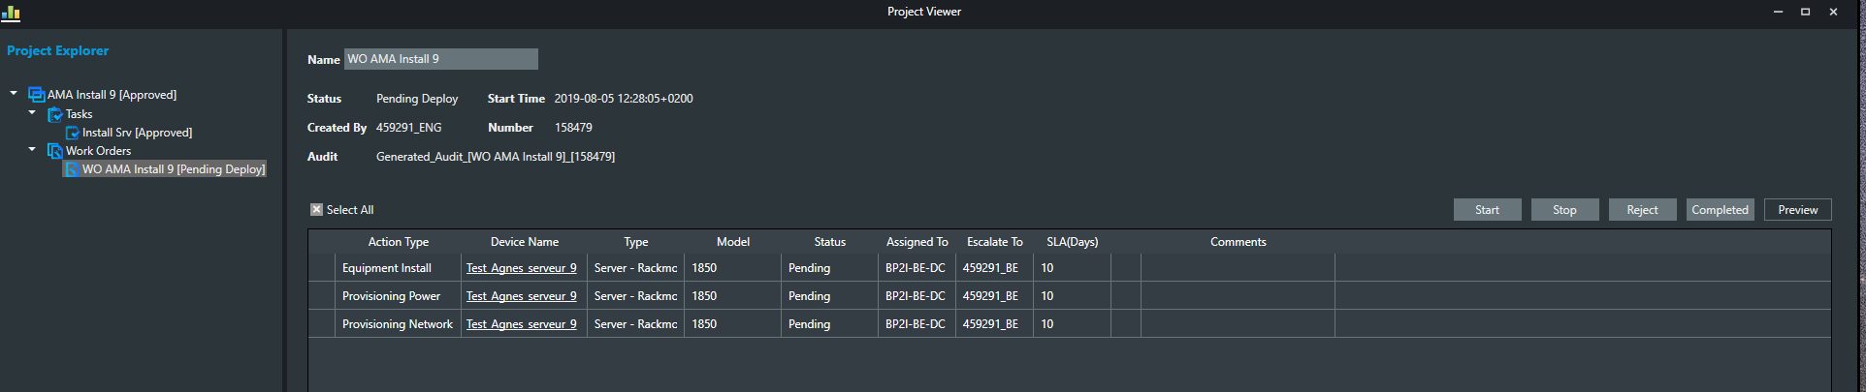

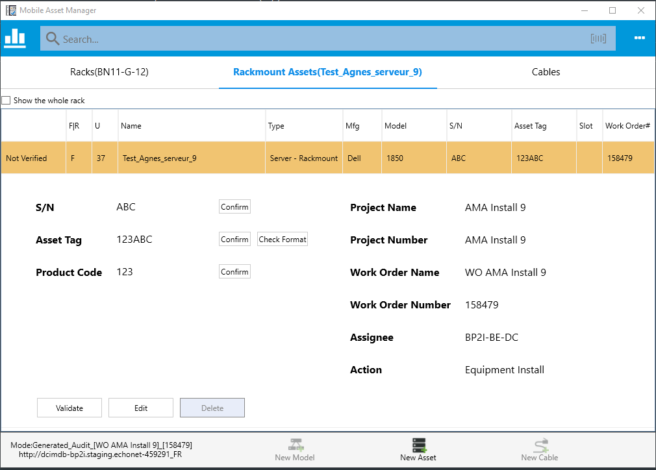

User 459291_FR can do « Validate ».

We expect that « Validate » works only with user 459291_BE and not with user 459291_FR as it is assigned to user 459291_BE.